WHITE PAPER
Local LLM + RAG Powered SOP Chatbot
How a Locally-Hosted AI Model Answers Only From Your Company's SOPs
Built on Angular + PHP Laravel, running entirely on local/on-premise hardware

Version 2.0

Objective
This chatbot runs a small AI language model (an LLM) entirely on local, on-premise hardware — no cloud, no internet dependency, no data ever leaving the company's servers. It answers employee questions about internal SOPs, but only using the company's own SOP content — never from the model's general training knowledge.
This is done using an approach called RAG (Retrieval-Augmented Generation): the system finds the exact relevant piece of the SOP for a given question, hands only that piece to the AI, and the AI writes a natural, conversational answer grounded strictly in that content.
Core Principle
The AI never freely answers from what it "knows." It is only ever shown the specific SOP text relevant to the question being asked, and instructed to use nothing else. This is what keeps every answer traceable back to an actual company document.

Plain-Language Explainer: How This Actually Works

Answering Only From Company Data
Think of it like an open-book exam where the AI is only allowed to look at one page handed to it — it cannot use anything from its own memory. Every time someone asks a question, four things happen:
- The system searches the SOPs and finds the exact paragraph(s) that match the question.
- It hands only that paragraph to the AI and instructs: "Answer using just this, nothing else."
- The AI reads that paragraph and writes the answer in natural, simple sentences.
- If nothing relevant is found, the AI is told to say "I don't have this information — please contact the concerned department" instead of guessing.
The AI never sees the whole SOP library at once — only the specific relevant piece, every single time.

Not "Training" the Model
The company's SOPs are not used to train or fine-tune the AI. Training would mean permanently changing the model's internal parameters — expensive, slow, and it would need to be redone every time an SOP changes. Instead, the system simply retrieves the right paragraph and hands it to the model fresh on every request (this is RAG). Update an SOP today, and the bot reflects that change immediately — no retraining, no extra cost.

1. Which Small Models We'll Use
Both models run 100% locally via Ollama — a free, open-source tool for running AI models on your own hardware. Neither model requires internet access to run.
Model | Purpose | Size | Approx. VRAM Needed
Llama 3.1 8B Instruct | Reads the retrieved SOP text and writes the natural-language answer | 8 billion parameters (Q4 quantized) | ~5.5–6 GB
Qwen2-VL-2B-Instruct | Reads and understands any image an employee uploads (screenshots, forms, photos of documents) | 2 billion parameters (Q4 quantized) | ~1.5–2 GB
nomic-embed-text | Converts SOP text and questions into searchable vectors for retrieval (not a chat model) | ≈137 million parameters | <1 GB

Both Llama 3.1 8B and Qwen2-VL-2B are free, open-source, and can be downloaded and run with a single command once Ollama is installed (e.g. ollama run llama3.1:8b). Neither model is trained further — they're used exactly as released, with company data supplied only at question-answering time.

2. System Architecture — Angular + Laravel + Local LLM
The chatbot fits directly into the existing Angular + PHP Laravel stack. Two new local pieces are added: a small RAG service that handles search, and Ollama, which runs the AI models.
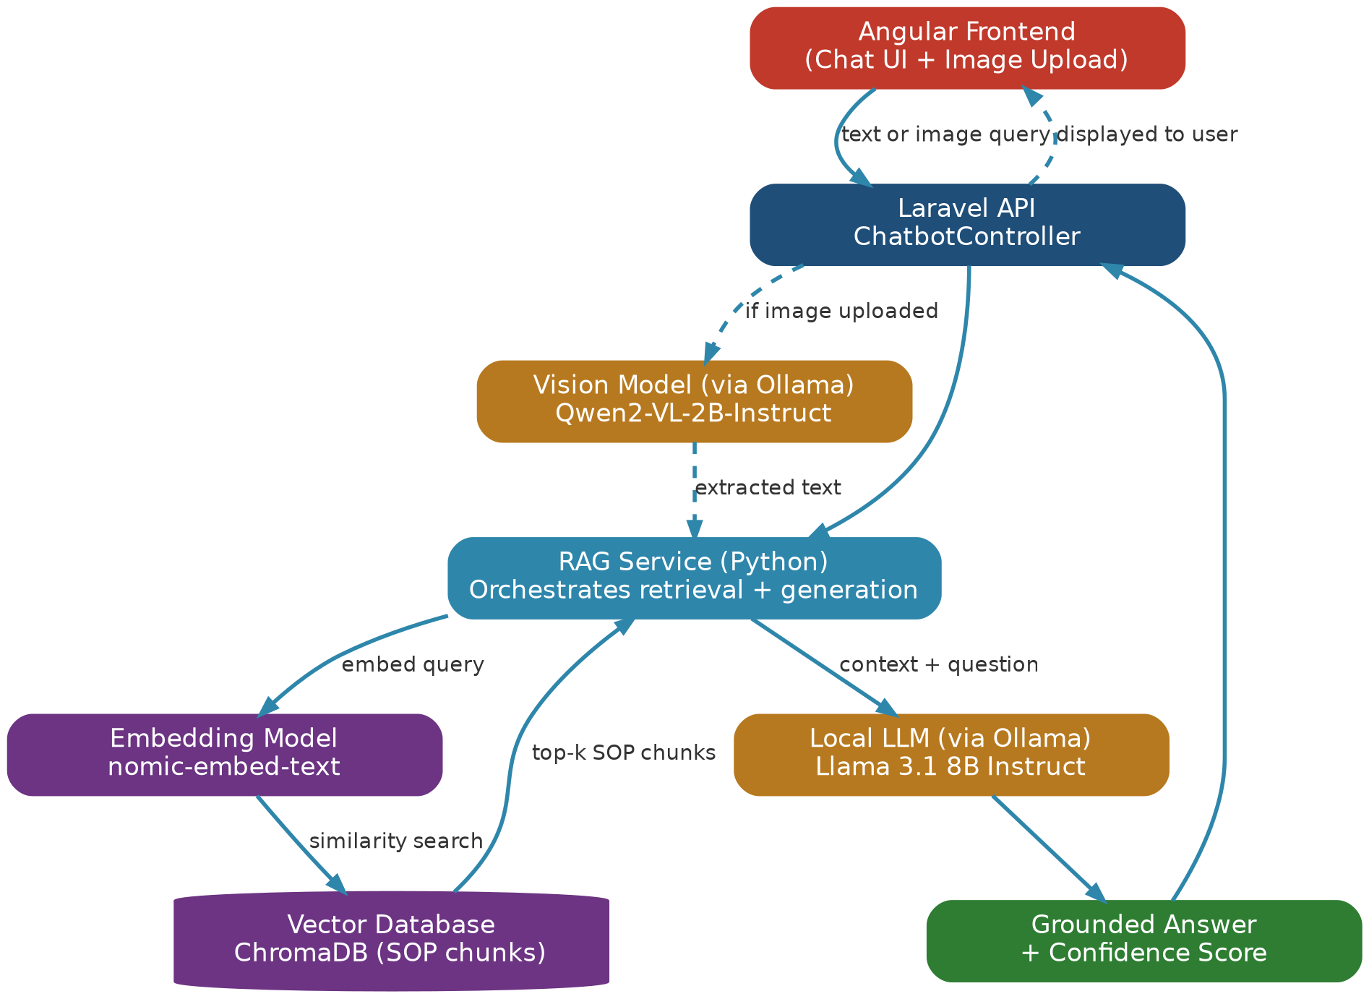
Figure 1: Full request flow — both typed questions and uploaded images pass through the same RAG service before reaching the language model.
- Angular — the chat interface employees type into (and where they can upload an image if needed).
- Laravel — exposes a simple API endpoint, receives the question, forwards it to the RAG service, and returns the final answer. Laravel doesn't need to know anything about embeddings or the AI model internally.
- RAG Service (Python) — the component that actually finds the right SOP content and talks to the AI model.
- Ollama — runs Llama 3.1 8B and Qwen2-VL-2B locally, serving them over a local address that only the RAG service talks to. Nothing here touches the internet.
- Vector Database (ChromaDB) — stores the company's SOPs, pre-processed into searchable chunks.

3. How Answers Are Generated — The RAG Pipeline
This is the exact step-by-step journey of one question, from being typed in Angular to an answer appearing on screen.
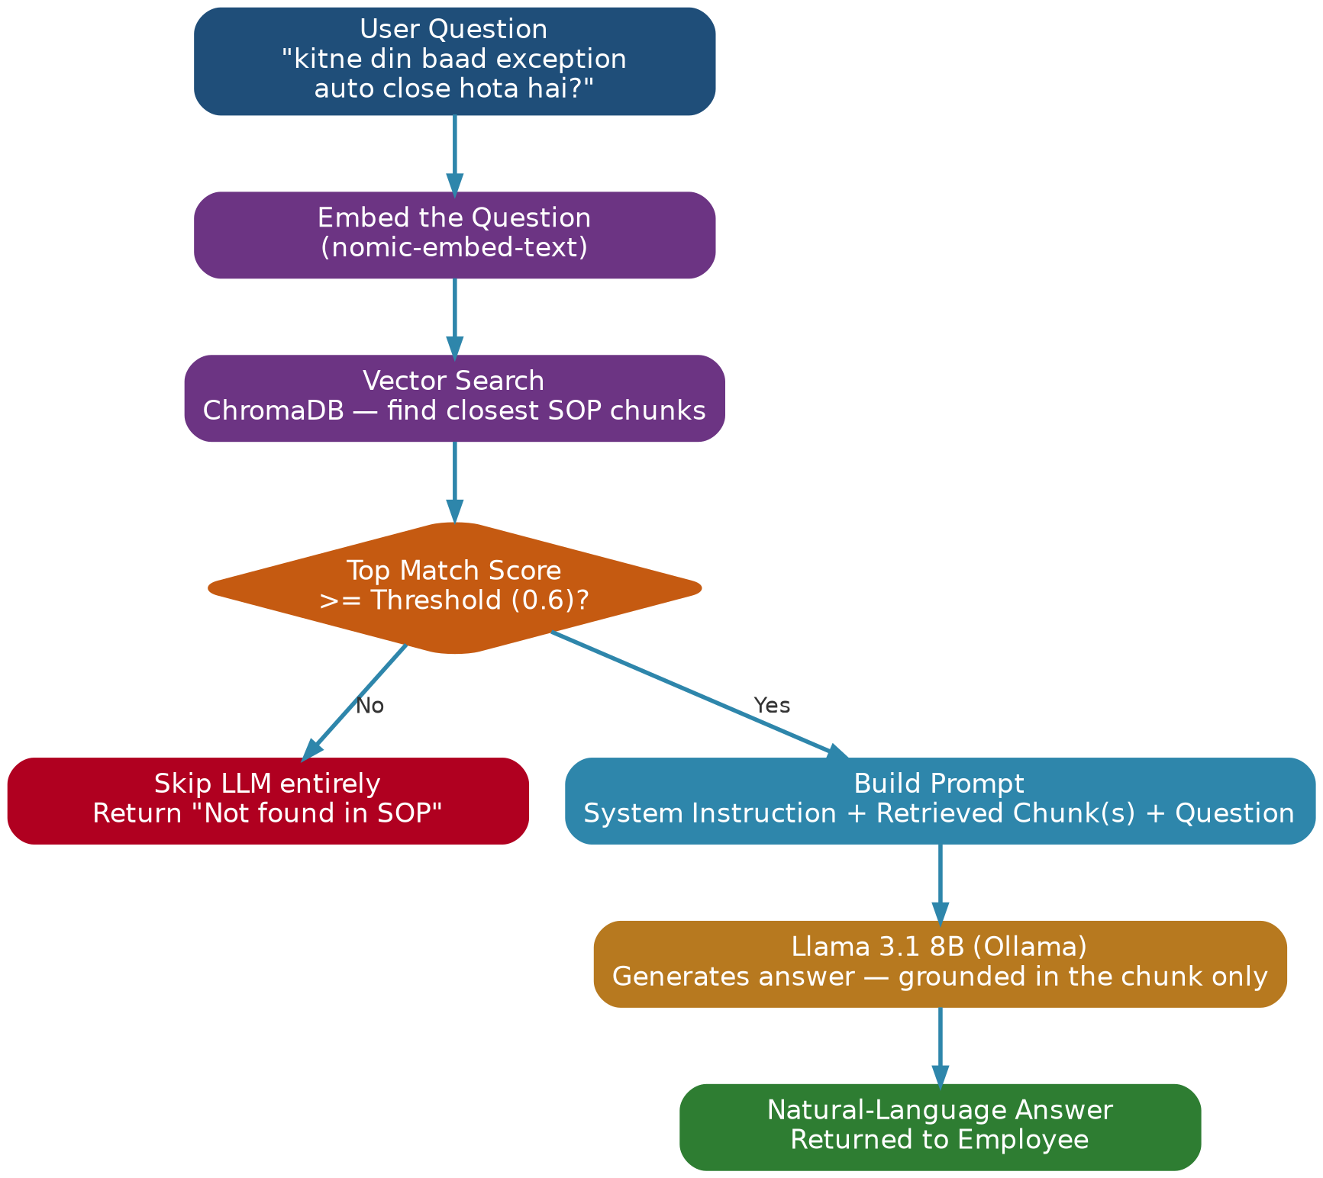
Figure 2: One query's full journey — to a grounded answer, or a clean fallback if nothing relevant exists in the SOPs.
Walked through with a real example — query: “kitne din baad exception apne aap close ho jata hai”
- The question is converted into a vector (a numerical representation of its meaning) using nomic-embed-text.
- ChromaDB is searched for the SOP chunks whose meaning is closest to that vector — in this case, the “Exception Automatic Closure” section.
- If the closest match is too weak (below a set confidence threshold), the AI model is skipped entirely and a fallback message is returned directly — the AI never gets a chance to guess.
- If the match is strong, that chunk plus the original question are placed into Llama 3.1 8B's prompt, along with a strict system instruction to use only that content.
- Llama 3.1 8B generates the final answer: “If an exception stays in the same status for more than 90 days — except while it's in 'Monitor' status — it gets automatically closed. Its status changes to Closed and it becomes Inactive.”

4. What Your SOPs Need to Contain
The better structured the SOPs are, the more accurately the retrieval step finds the right content to hand the AI. Keep it simple:
- A clear, specific heading per topic (“Password Reset”, not “Miscellaneous”).
- One topic per section — don't mix unrelated processes on the same page.
- Steps written one by one, not as a dense paragraph.
- The exact words employees might type (“forgot password”, “login problem”) mentioned somewhere in the section.
- Any abbreviation spelled out in full at least once (VPN = Virtual Private Network).
- Important instructions always written as text — never kept only inside a screenshot.

5. Why This Approach Is Safe & Controlled
Running an AI model always raises the question: what stops it from making things up? Control here comes from several layers working together:
- Retrieval scoping (the main safeguard): the AI physically never receives the full SOP library — only the 1–3 matched chunks per question. It cannot answer from what it was never shown.
- Strict system prompt: an explicit instruction to answer only from the given context, and to give a fixed fallback reply when the answer isn't present.
- Low temperature setting (0.1–0.3): keeps the model factual and literal instead of creative.
- Threshold-based fallback: if retrieval doesn't find a strong enough match, the AI is skipped entirely and a “not found” message is returned directly.
- No internet or external tool access given to the model — it is pure text-in, text-out, running entirely on local hardware, so company data never leaves the premises.
Sample System Prompt
"You are an internal assistant for [Company]. Answer strictly using the SOP context provided below. Do not use outside knowledge. If the answer is not present in the context, reply exactly: 'This isn't covered in our SOPs — please contact the concerned department.'"

6. Example Conversations — Real Outputs From an SOP
The examples below use a real client SOP (“Exception Management” on the ASPIA platform) to show exactly what the chatbot outputs.

Example 1
Employee
How do I submit a new exception request?

Chatbot
Log in to ASPIA and go to the Exceptions module, then click "New Exception." Fill in the description, justification, and duration, attach any supporting documents, and choose the Exception Owner. Once you save it, the request goes to "New" status and an email is sent to the first approver.

Example 2 — a narrow sub-question
Employee
agar maine manager level 2 set kiya hai to kis kis ko notification jayega

Chatbot
With Manager Levels set to 2, notifications go to the user's direct manager and that manager's manager.

Example 3 — nothing relevant found
Employee
what's the weather like today

Chatbot
This isn't covered in our SOPs — please contact the concerned department.

A Few More, Quickly
Question | Chatbot's Answer
Exception kab automatically close hota hai? | If it stays in the same status for more than 90 days (except while in ‘Monitor’ status), it's automatically closed and marked Inactive.
What happens if the Business Head rejects a request? | The request status changes to ‘Closed,’ the state becomes ‘Inactive,’ and an email is sent to the Exception Owner informing them of the rejection.
Can I edit my request after it's approved? | Once approval starts, only the assigned approver can change the Category or Exception Owner. Doing so restarts the whole approval workflow from the beginning.

7. Hardware & Deployment Requirements
Since this runs on company infrastructure, hardware should be sized to expected usage — how many employees may query the bot at once.
Tier | GPU VRAM | Example Cards | Suitable For
Minimum | 6 GB | RTX 3060 (6GB), RTX 4050 | Both models running, fits tightly — fine for a pilot or single concurrent user.
Recommended | 8–12 GB | RTX 3060 (12GB), RTX 4060 Ti, RTX A2000 | Comfortable headroom, a handful of concurrent users.
Production | 16 GB+ | RTX 4080, RTX A4000, L4, A10 | Multiple concurrent employees, room to upgrade models later.

- System RAM: 16 GB minimum, 32 GB comfortable.
- Disk: 20–30 GB free for model files, the vector database, and SOP content.
- OS: Linux (Ubuntu) is the standard choice for production; Windows Server also works via Ollama.
- Everything above runs on-premise — no cloud AI service, no per-query API cost, no company data ever transmitted externally.

8. Recommendations Summary
- Use Llama 3.1 8B Instruct for answering, and Qwen2-VL-2B-Instruct for reading uploaded images — both run fully local via Ollama.
- Never let the AI see the full SOP library — always retrieve and pass only the relevant chunk(s).
- Keep the system prompt strict, temperature low, and always have a hard fallback for weak matches.
- Structure SOPs with clear headings, one topic per section, and step-by-step writing — this directly improves retrieval accuracy.
- Size the GPU to expected concurrent usage using the tiers in Section 7.

Bottom Line
A locally-hosted LLM, combined with retrieval that only ever shows it the company's own SOP text, gives natural, conversational answers while keeping every response grounded, private, and fully on-premise.

